**1.INTRODUCTION**

The COVID‑19 pandemic, also known as the coronavirus pandemic, is an ongoing pandemic of coronavirus disease 2019 (COVID‑19) caused by severe acute respiratory syndrome coronavirus 2 (SARS‑CoV‑2).The coronavirus is thought to spread mainly from person to person. This can happen between people who are in close contact with one another.Coronavirus can also spread from contact with infected surfaces or object.India is recording 65,000 new coronavirus cases daily (on an average), when compared to 55,000 to 60,000 cases last week. As the number of daily cases continues to increase at an alarming rate, experts are worried that the situation may deteriorate pretty soon, making India the top nation impacted by the coronavirus pandemic.

**2.1.OVERVIEW:**

Some time ago, the WHO has announced a state of emergency concerning the coronavirus which causes the illness COVID-19, and asked companies to take the required precautionary measures in order to protect both employees and the company. As we all know that the most important step to stop the spread of corona virus is to take safety measures and precautions .

One of the main ways in which COVID-19 spreads is by touching surfaces and objects.

Although SARS-CoV-2 can be detected on these surfaces for a particular length of time, the viability of the virus, due to environmental and other conditions, is not known.So, a clean desk policy is now a must.

**2.2.PURPOSE**:

1.Unable to Track Sanitization procedures in co-working spaces.

2.Lack of clarity about safety measures implemented in the offices.

3.Risk of spreading of virus on hotspots like desktops,tablles,door handles,etc.

4.Manual checking on timely sanitization poses a threat of infection.

5.Regular Sanitization of workspaces is mandatory to maintain personnel safety in co-working spaces

**Solution**:

Develop a IOT based smart sanitization monitoring system for coworking spaces.

With the help of NFC ,make a smart time log sytem that is ableto track the sanitization timings as well as update to the user immediately without any human intervention.

**PROJECT FLOW:**

1.Cleaning staff must use this App to make a log regarding the sanitization activity at the office.

The staff who carries an NFC enabled device will sanitize the work space.

2.The NFC stickers will be attached to the various touchspots of the office like tables , devices, chairs ,handles , etc.

3.Once the NFC Tag is recognized,data is updated using the dynamoDb into the flask app immediately.

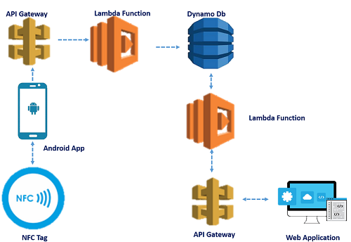

Tech Stack Used:AWS DynamoDb,PYTHON framework,FLASK,MITAPP,API gateway.

**PURPOSE**:

The flask web is able to recognize the time ,name and place at which a spot has been sanitized. This automaticly updated app reduces the risk of spreading of the virus, incase if a person had to scrutinize the sanitization procedure followed in the office by himself.

Since DynamoDb is a NOSQL database , data handling operations are very easily done.

**3.RESULT**

Flask Web app -http://localhost:5000/

App deployed using AWS -http://ec2-13-233-150-246.ap-south-1.compute.amazonaws.com:5000/

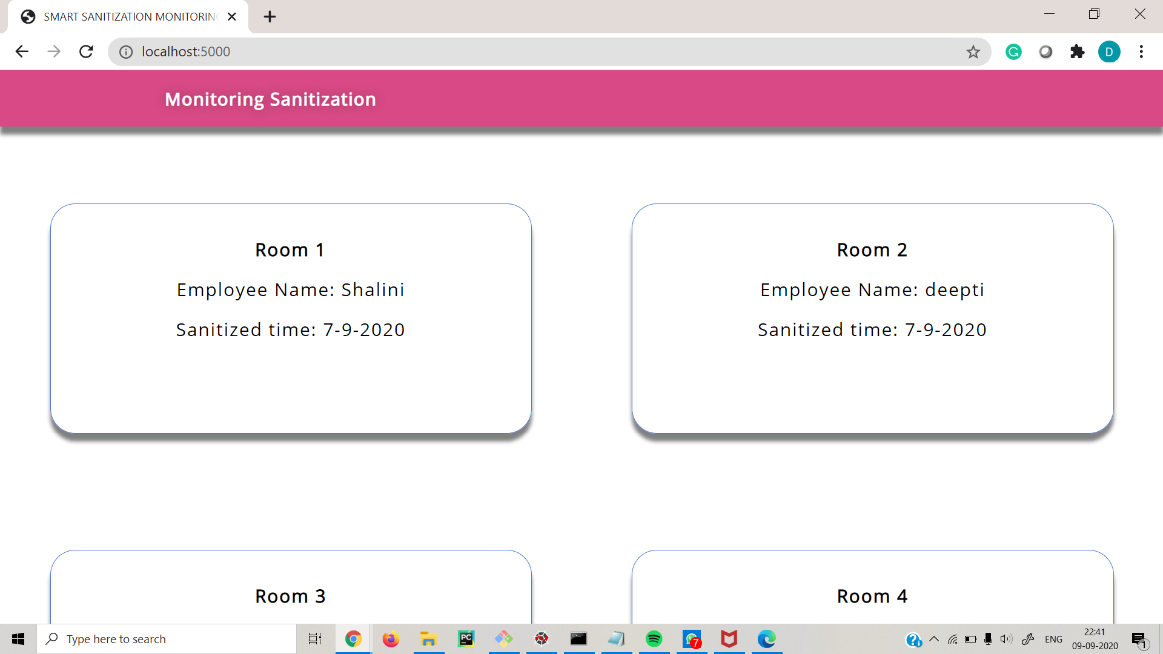

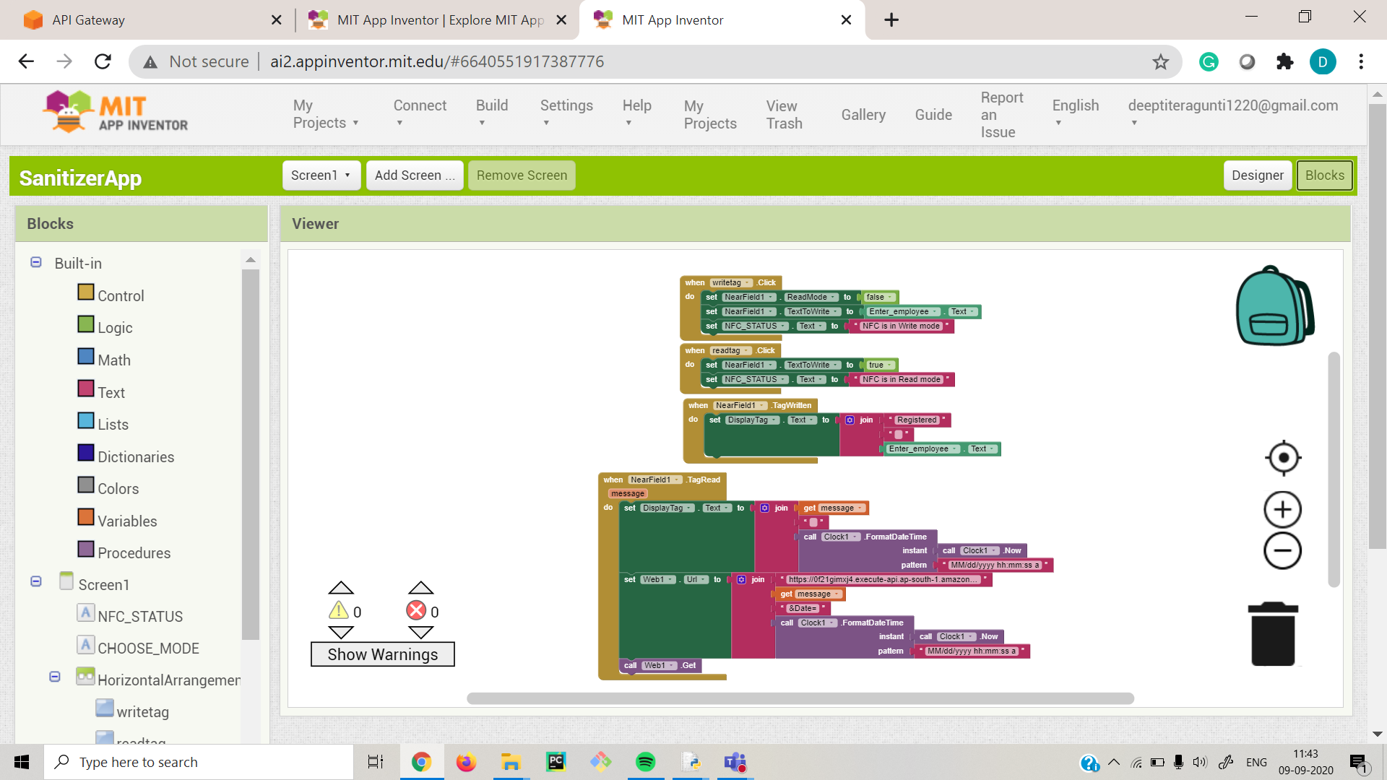

**4.APPLICATION**

It is really hard to get rid of germs and viruses, but we have to try it. Similarly, property managers and real estate owners should be well aware of the concerns and may be searching for how to address or monitor this.The smart system for sanitization monitoring can be used in various corporate offices,public work spaces and shops.Our application provides 24/7 insight into the hygiene of the building visitors via Predictive maintenance and refilling with IoT & NFC.

**FUTURE SCOPE**

Near field communication is a technology to transfer information between devices in close proximity using RF signals.  
NFC technology offers wide range of features from keyless access to smart tags for medical applications.

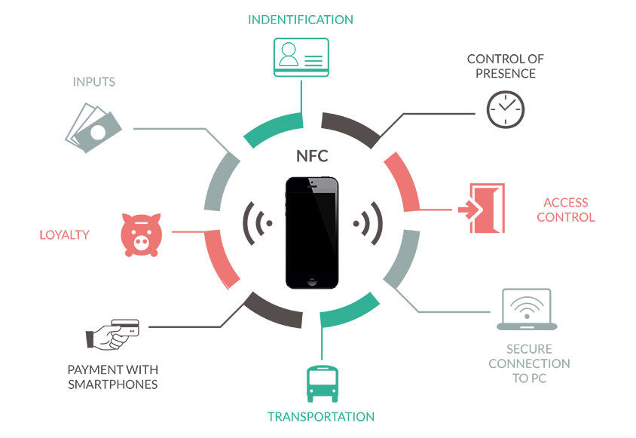

**ACKNOWLEDGEMENT**

I would like to thank Smart-Bridge Smart Interns for giving me this oppurtunity to work on this project .Im extremely thankful to the mentors Sandeep Sir and Pradeepti mam for teaching the concept of NFC IOT and providing us a hands on experience in working with aws services.